Lab 3
Q2: $D_{A}=\overline{X}A+XY$ , $D_{B}=\overline{X}B+XA$ , $Z=XB$ :-
A. State table: -
Present State |  |  |  | Next State
A | B | X | Y | D_{A} | D_{B} | Z
0 | 0 | 0 | 0 | 0 | 0 | 0
0 | 0 | 0 | 1 | 0 | 0 | 0
0 | 0 | 1 | 0 | 0 | 0 | 0
0 | 0 | 1 | 1 | 1 | 0 | 0
0 | 1 | 0 | 0 | 0 | 1 | 0
0 | 1 | 0 | 1 | 0 | 1 | 0
0 | 1 | 1 | 0 | 0 | 0 | 1
0 | 1 | 1 | 1 | 1 | 0 | 1
1 | 0 | 0 | 0 | 1 | 0 | 0
1 | 0 | 0 | 1 | 1 | 0 | 0
1 | 0 | 1 | 0 | 0 | 1 | 0
1 | 0 | 1 | 1 | 0 | 1 | 0
1 | 1 | 0 | 0 | 1 | 1 | 0
1 | 1 | 0 | 1 | 1 | 1 | 0
1 | 1 | 1 | 0 | 0 | 1 | 1
1 | 1 | 1 | 1 | 0 | 1 | 1

B. State diagram: -
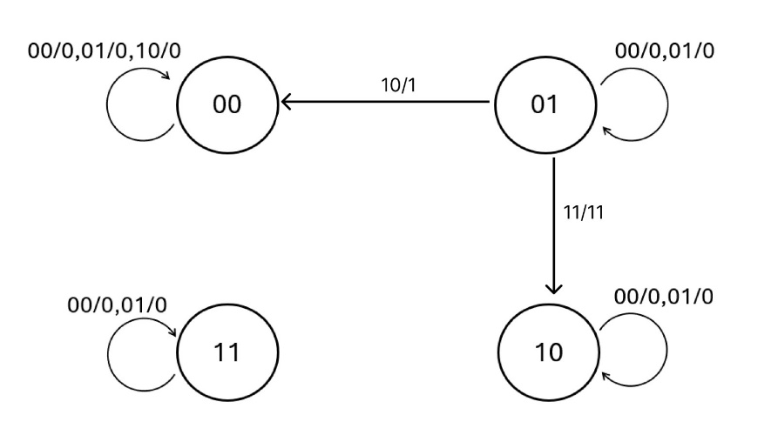
Q3: Derived Boolean expression of 3-bit counter using D Flip-Flop: -
$D_{3}={\overline{x}(A}_{1}(A_{2}⊕A_{0})+A_{2}\overline{A_{1})}$
$D_{1}={\overline{x}(A}_{1}⊕A_{0})$
$D_{0}=\overline{\overline{x}{(A}_{0})}$

State diagram:-
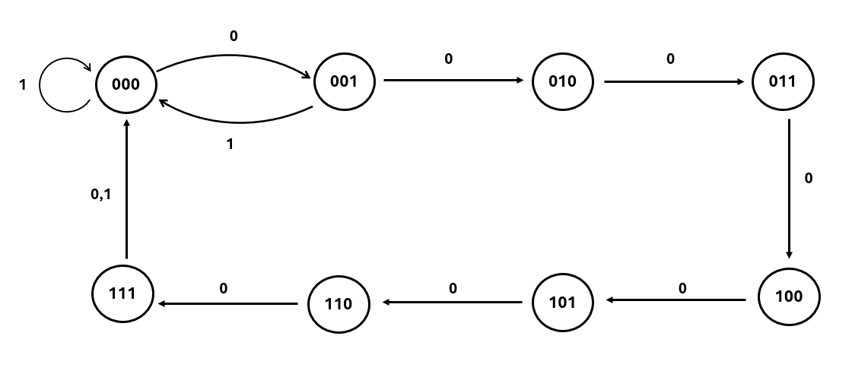
Q4: Starting from state 00 in the following state diagram, show the state transition sequence and output sequence for input sequence 0101101111: -
A/1. State Transition Sequence for input 0101101111: -
00 → 00 → 01 → 10 → 11 → 10 → 11 → 11 → 11 → 11 → 11
A/2. Output Sequence: -
0, 0, 1, 0, 1, 0, 0, 0, 0, 0
B. State table: -
Present State |  |  | Next State
A | B | X | D_{A} | D_{B} | Y
0 | 0 | 0 | 0 | 0 | 0
0 | 0 | 1 | 0 | 1 | 1
0 | 1 | 0 | 1 | 0 | 0
1 | 0 | 1 | 1 | 1 | 1
1 | 1 | 0 | 1 | 0 | 0
1 | 0 | 1 | 1 | 1 | 0
1 | 1 | 1 | 1 | 1 | 0
1 | 1 | 1 | 1 | 1 | 0
1 | 1 | 1 | 1 | 1 | 0
1 | 1 | 1 | 1 | 1 | 0

Present State |  |  | Next State
A | B | X | D_{A} | D_{B} | Y
0 | 0 | 0 | 0 | 0 | 0
0 | 0 | 1 | 0 | 1 | 1
0 | 1 | 0 | 1 | 0 | 0
0 | 1 | 1 | 1 | 1 | 0
1 | 0 | 0 | 1 | 0 | 0
1 | 0 | 1 | 1 | 1 | 0
1 | 1 | 0 | 1 | 1 | 0
1 | 1 | 1 | 1 | 1 | 1
Q5: State table of A sequential circuit has two flip-flops A and B, one input X, and one output Y : -

Q6: Draw the state diagram of the rotator, and the equations for each D flip-flop: -
A. Equations: -
Current states are $Q_{3},Q_{2},Q_{1},Q_{0}$.
$D_{0}=\overline{Y}X_{0}+YQ_{1}$
$D_{1}=\overline{Y}X_{1}+YQ_{2}$
$D_{2}=\overline{Y}X_{2}+YQ_{3}$
$D_{3}=\overline{Y}X_{3}+YQ_{0}$

B. State diagram: -
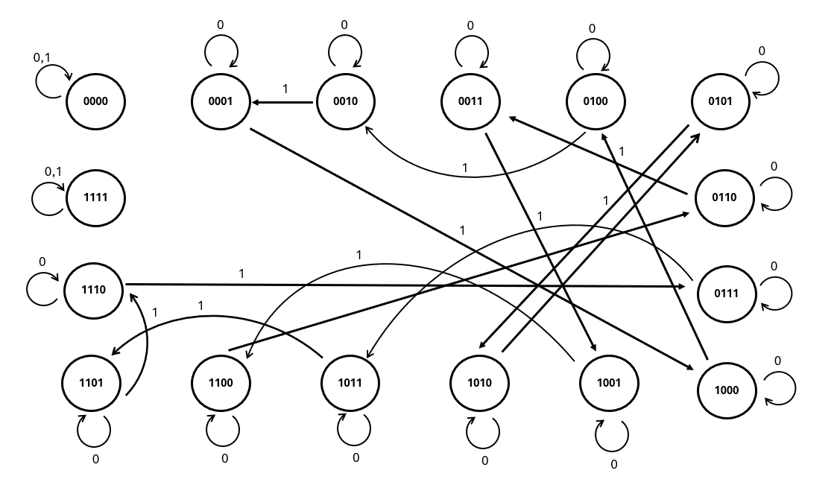
Q7: Work on the following state diagram: -
A. Draw the state-machine diagram: -
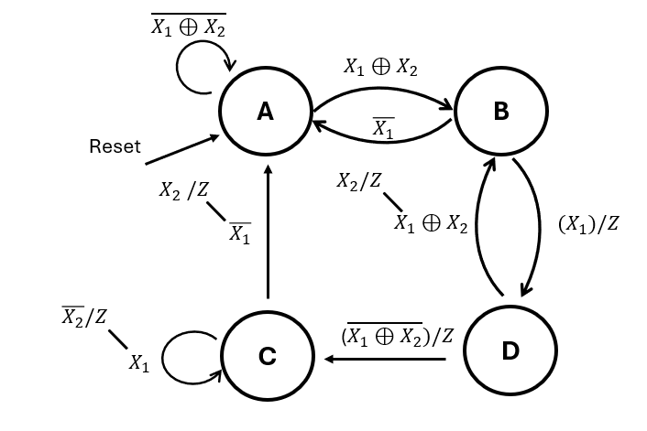

B. Perform state assignment, write down the Flip-Flop Input Equations and Output Equations, then optimise it: -
Present State |  |  |  | Next State
A | B | $$X_{1}$$ | $$X_{2}$$ | D_{A} | D_{B} | Z
0 | 0 | 0 | 0 | 0 | 0 | 0
0 | 0 | 0 | 1 | 0 | 1 | 0
0 | 0 | 1 | 0 | 0 | 1 | 1
0 | 0 | 1 | 1 | 0 | 0 | 0
0 | 1 | 0 | 0 | 0 | 0 | 0
0 | 1 | 0 | 1 | 0 | 0 | 0
0 | 1 | 1 | 0 | 1 | 0 | 1
0 | 1 | 1 | 1 | 1 | 0 | 1
1 | 0 | 0 | 0 | 1 | 1 | 1
1 | 0 | 0 | 1 | 0 | 1 | 1
1 | 0 | 1 | 0 | 0 | 1 | 0
1 | 0 | 1 | 1 | 1 | 1 | 1
1 | 1 | 0 | 0 | 0 | 0 | 1
1 | 1 | 0 | 1 | 0 | 0 | 0
1 | 1 | 1 | 0 | 1 | 1 | 1
1 | 1 | 1 | 1 | 1 | 1 | 0

